**Homework 0**

1. Create directory animals in /home

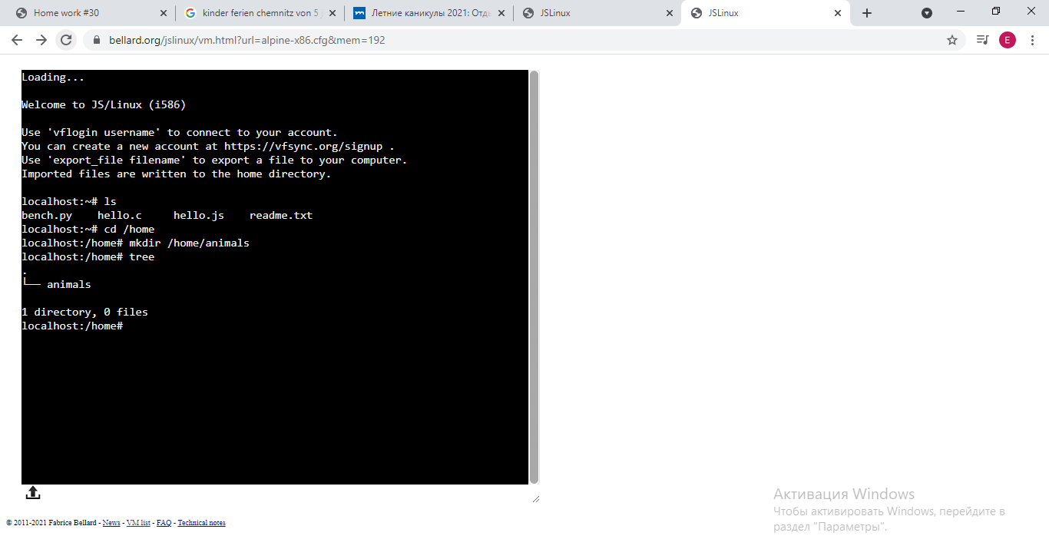

1. Create subdirectories dogs, cats, fish in animals directory, created earlier

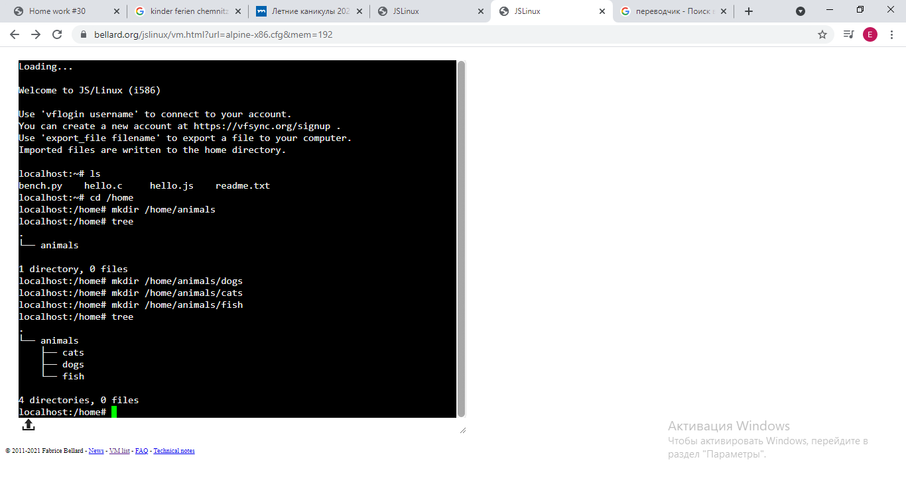

1. Add files pluto, nemo and garfield to directories, created earlier ( pluto goes to dogs, garfield goes to cats)

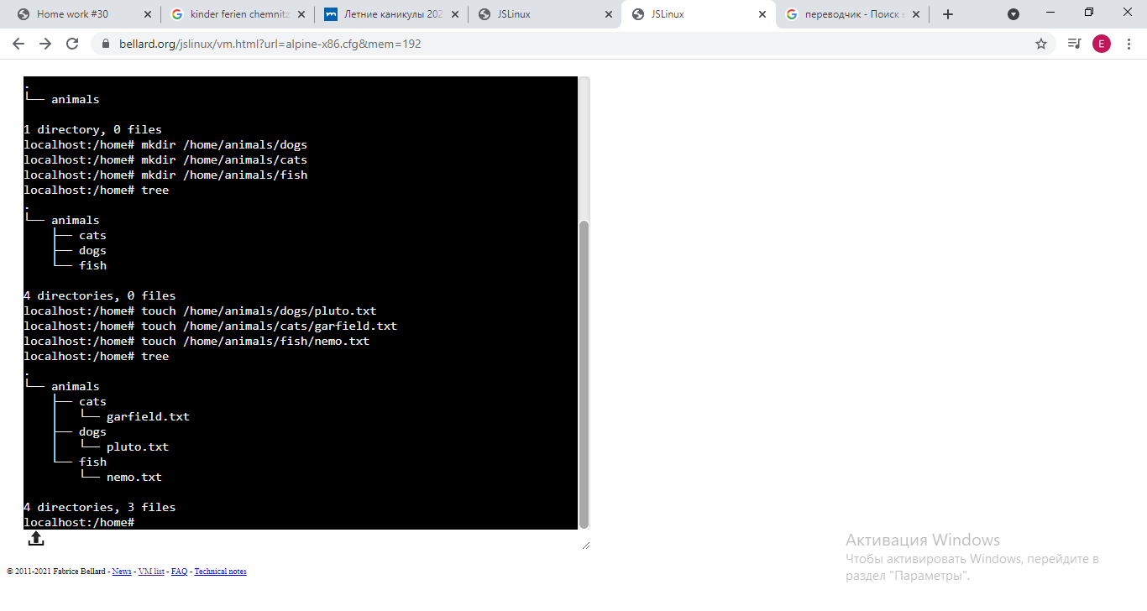

1. In /tmp directory create file adam

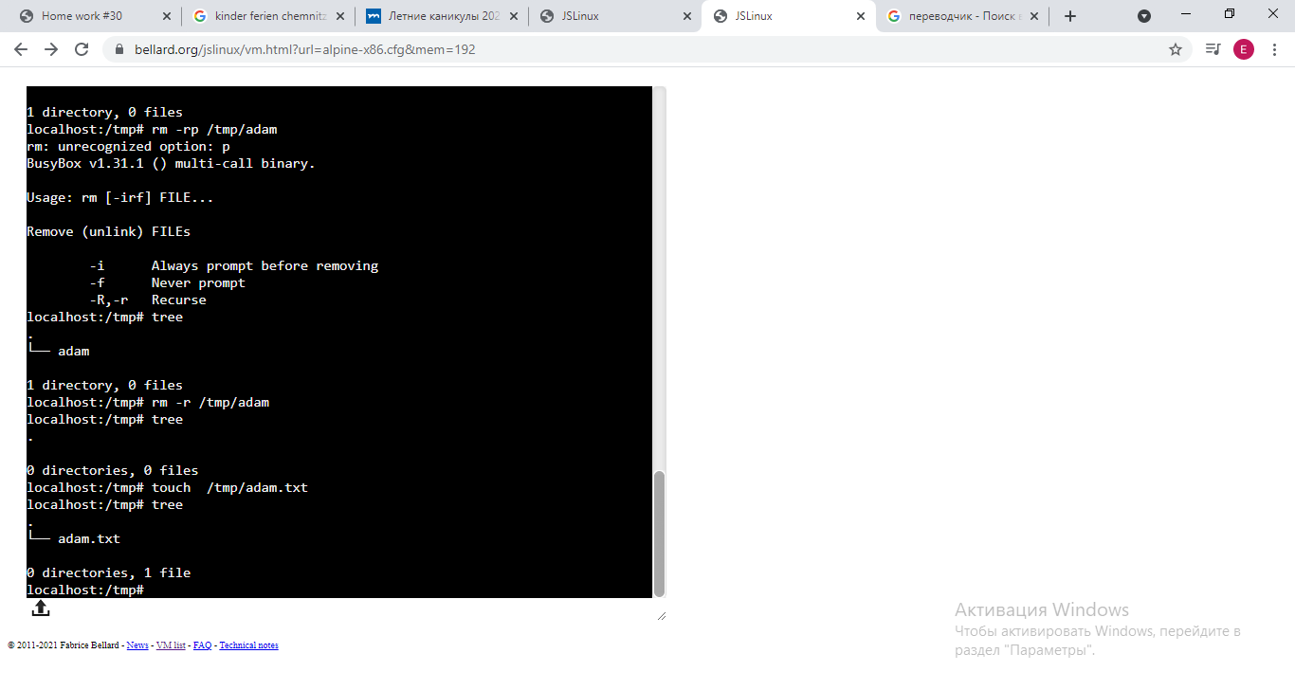

1. Copy file adam to /home/humans ( create directory)

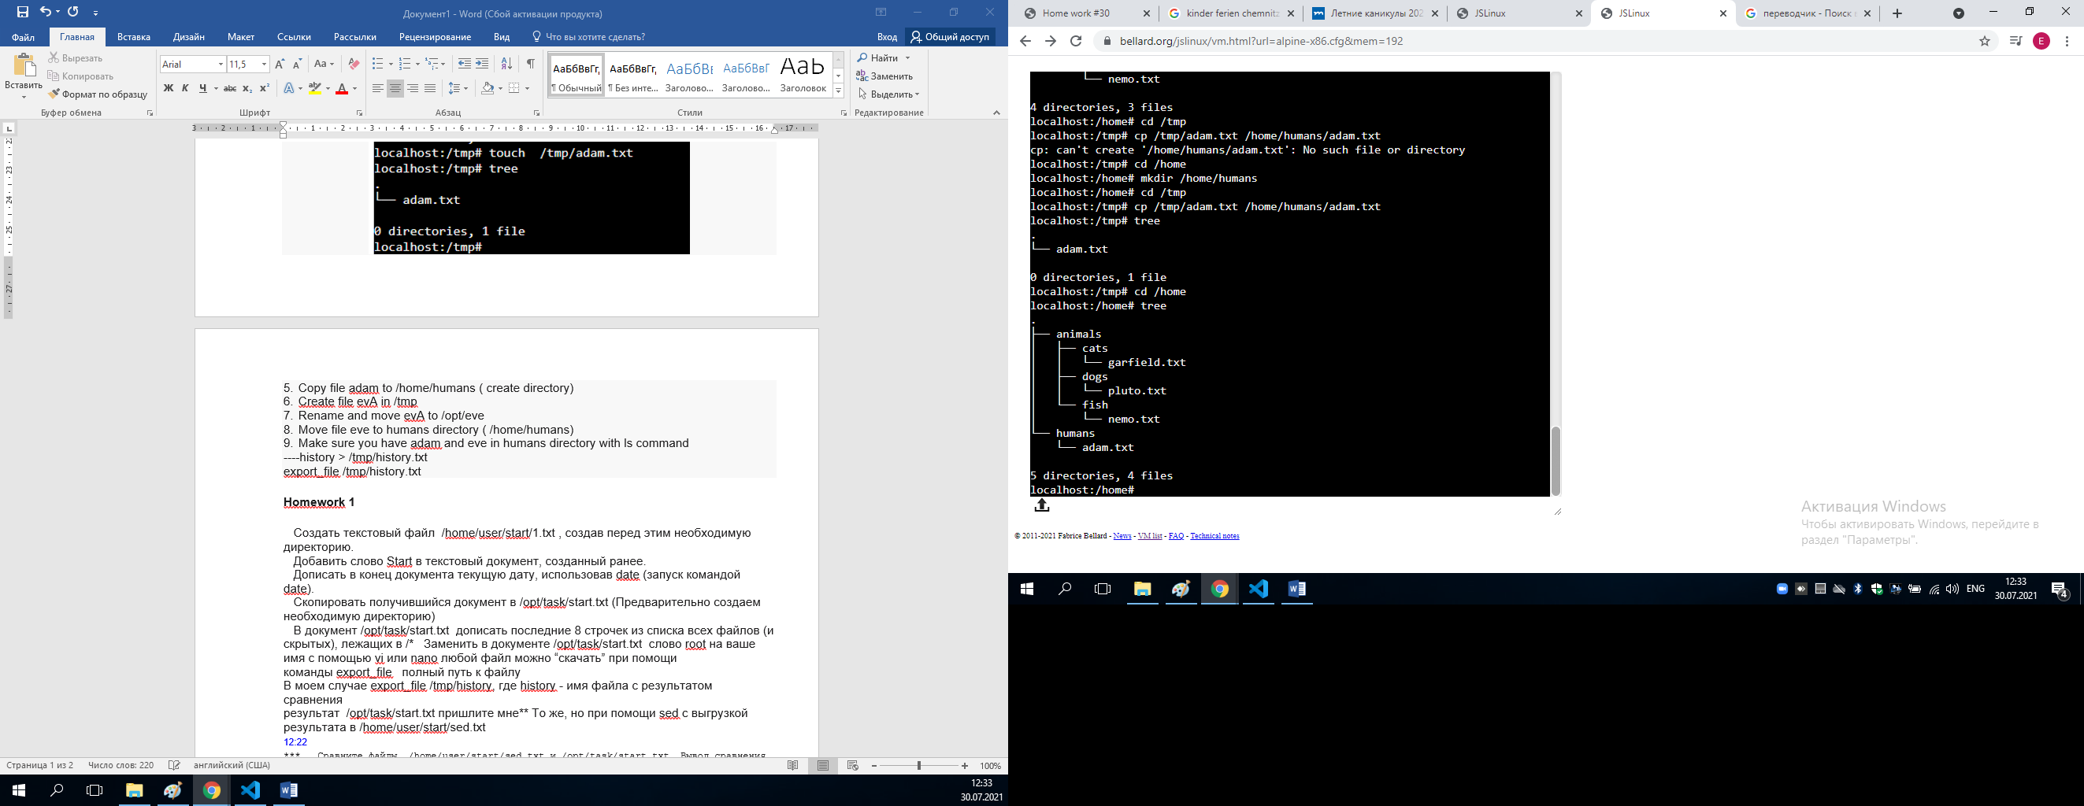



1. Create file evA in /tmp

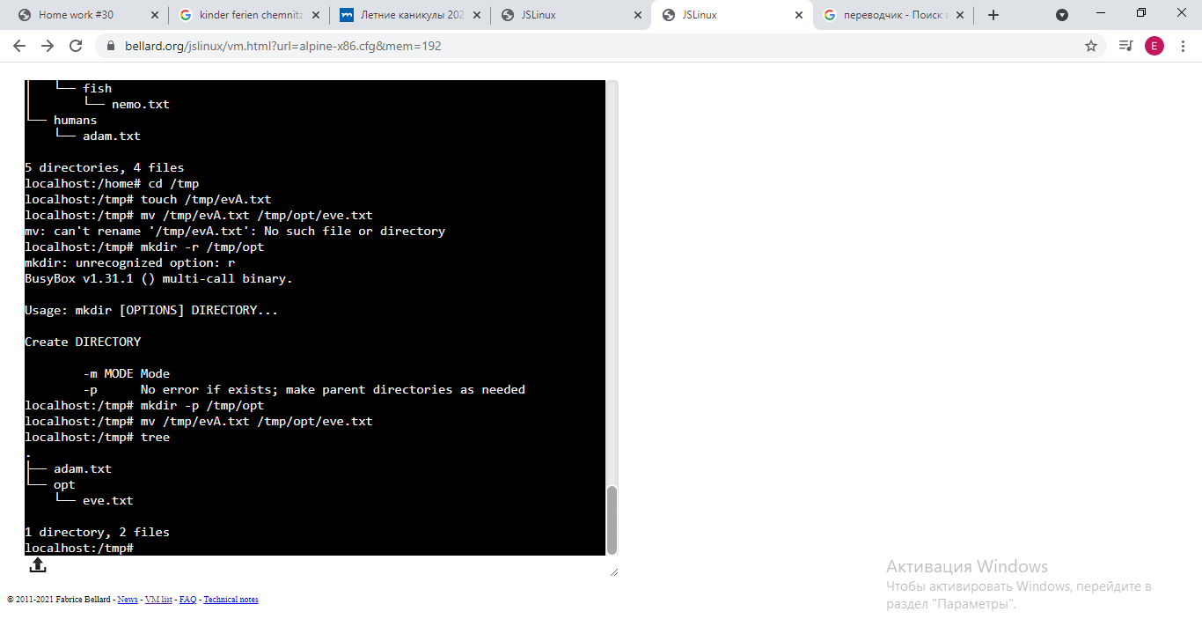

1. Rename and move evA to /opt/eve



1. Move file eve to humans directory ( /home/humans)

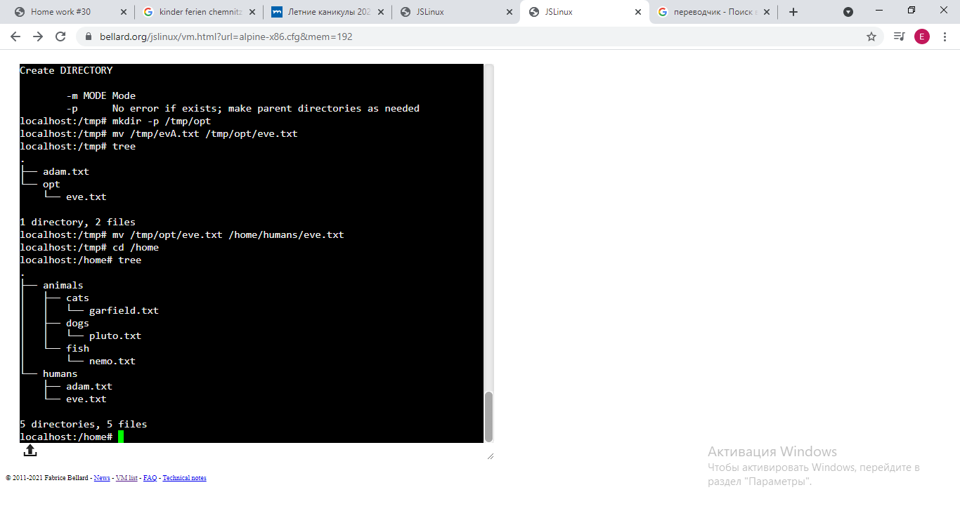

1. Make sure you have adam and eve in humans directory with ls command

----history > /tmp/history.txt  
export_file /tmp/history.txt